**Code Snips**

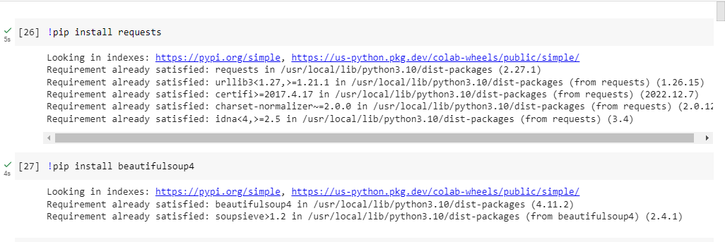

Web scraping data libraries using Requests and BeautifulSoup

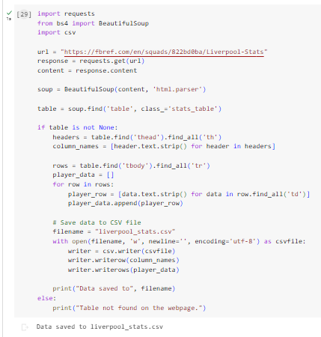

Python code to create csv dataset through website data scraping using Requests and BeautifulSoup and CSV file saving

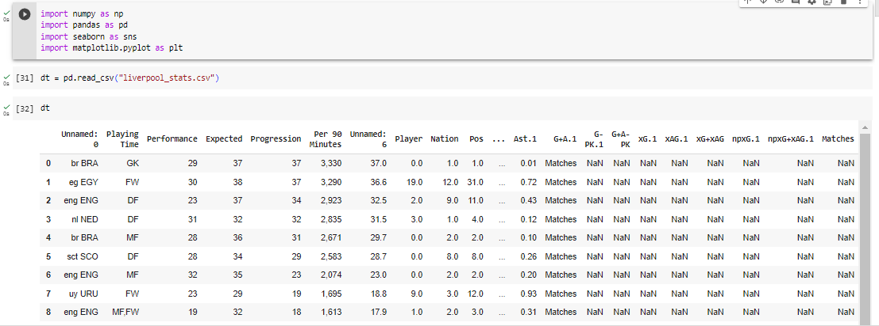

Python analysis library importation and scraped dataset reading

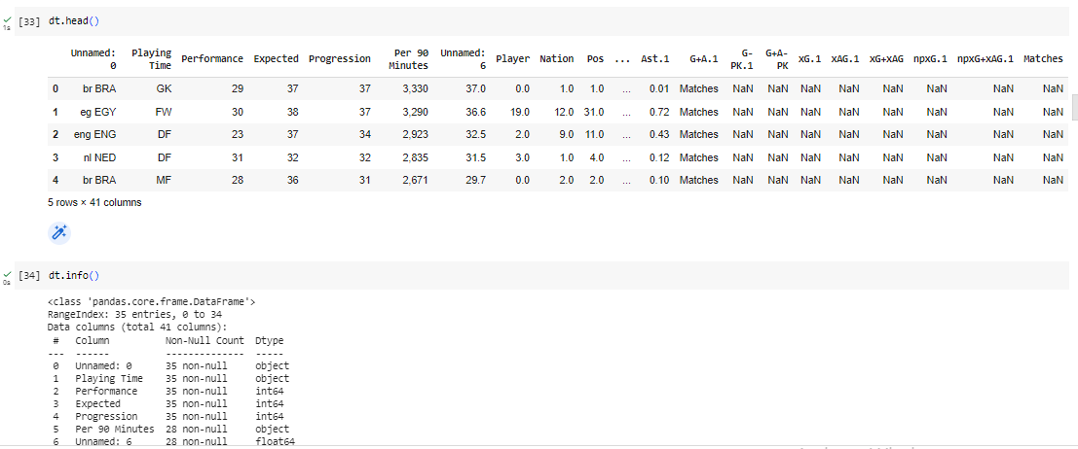

First five data and information of the scraped dataset using head() and info() function

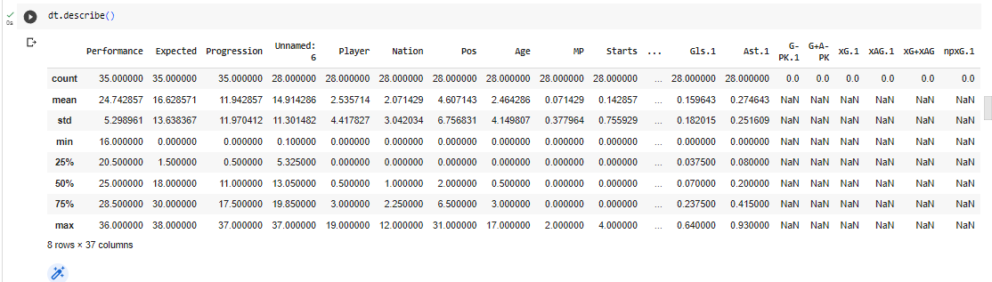

Description of the entire web scraped dataset

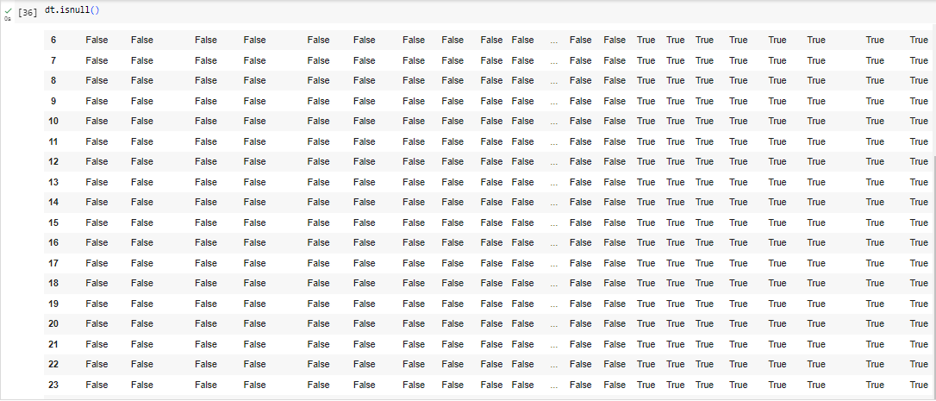

Checking for the null values in the scraped dataset

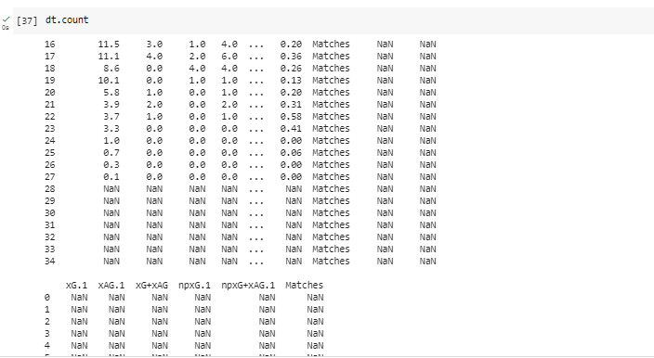

Value counts of all the columns of the scraped dataset

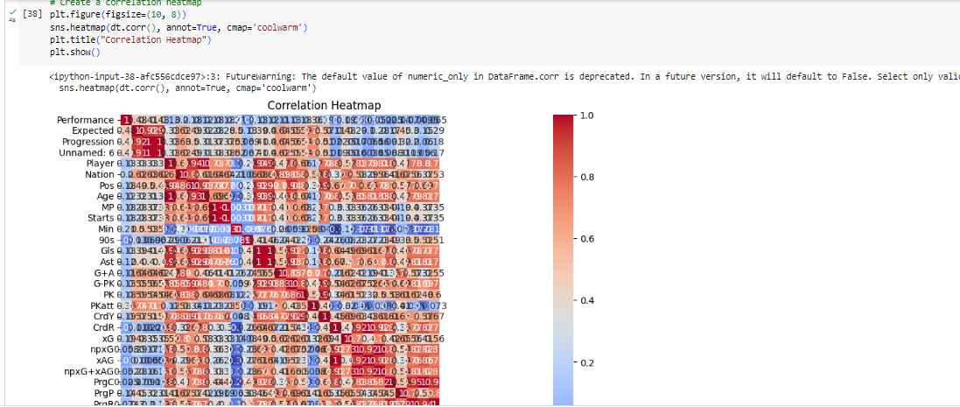

Correlation heat map of the scraped dataset parameters

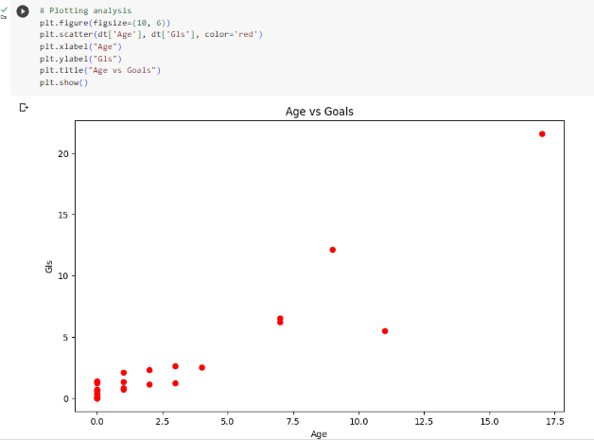

Scatter plot analysis between Age and Goals from the scraped dataset

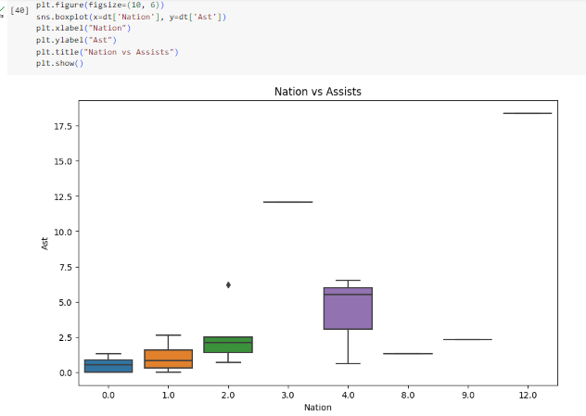

Box plot graph for the parameters Nation vs Assists from the scraped dataset

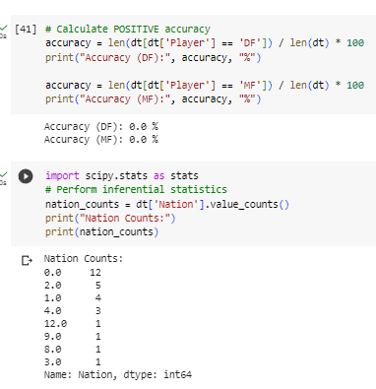

Positive accuracy value and the inferential statistics for the Nation in the scraped dataset

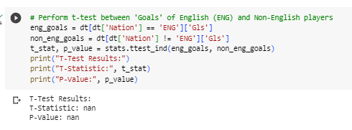

NaN values for the T-test of Goals due to data unavailability from scraping

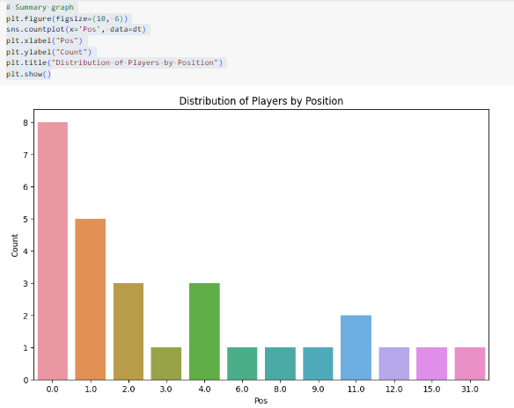

Summary Graph for the player distribution by Position